Three Years of Mars Cartography
Using HRSC Data
J. Albertz¹, S. Gehrke¹, H. Lehmann¹, M. Wählisch²,
G. Neukum³, and the HRSC Co-Investigator Team
¹ Technische Universität Berlin, Geodesy and Geoinformation Science, Secretariat H12,
Straße des 17.Juni 135, D-10623 Berlin, {albertz|stephan|h.lehmann}@igg.tu-berlin.de
² German Aerospace Center (DLR), Institute of Planetary Research, Berlin-Adlershof, Rutherfordstraße 2,
D-12489 Berlin, marita.waehlisch@dlr.de
³ Freie Universität Berlin, Institute of Geological Sciences, Malteserstr. 74-100, D-12249 Berlin, gneukum@zedat.fu-berlin.de

Abstract
Since January 2004, the High Resolution Stereo Camera (HSRC) on board of Mars Express is imaging the Martian surface. The data acquired provide both full color and systematic stereo; it is well suited to derive Digital Terrain Models, color orthoimages, and, based on that, topographic and thematic maps. The standard map series of the Mars Express mission is the Topographic Image Map Mars 1:200,000. Map production is carried out using the cartographic software package Planetary Image Mapper (PIMap), which has been developed at Technische Universität Berlin. An overview of HRSC maps of the past three years is given. This comprises the sheets of the standard series as well as related topographic and also thematic map products.

Introduction
The High Resolution Stereo Camera (HRSC) on the European Mars Express mission began operation in January 2004. The camera is returning both full color and multiple stereo – a unique data set for systematic derivation of Digital Terrain Models (DTM), color orthoimages, and, based on that, high quality cartographic products, which are mainly based on the cartographic concepts of the Topographic Image Map Mars 1:200,000 series (Albertz et al., 2004; Kirk, 2005; Lehmann et al., 1997). The series’ layout scheme is flexible to the generation of special target maps, thematic maps, and related products.
In order to automate the map generation process, the cartographic software package Planetary Image Mapper (PIMap) has been developed at Technische Universität Berlin (TUB) by Gehrke et al. (2006b). Using this software, map production is carried out at TUB in cooperation with the German Aerospace Center (DLR), which is responsible for photogrammetric processing of HRSC data (Gwinner et al., 2005; Scholten et al., 2005). Other HRSC team members are involved, especially with regard to thematic mapping.
An average sheet of the Topographic Image Map Mars 1:200,000 displays approximately 120x120 km; considering an HRSC image width of 60 km in highest resolution of 12 m/pixel, it is evident that mosaics of adjacent orbits are necessary to cover the mapped area. Therefore, especially in the early stage, map sheets needed to be adapted to individual orbits by location and/or scale. The first maps within the regular sheet lines could be generated in summer 2004. Until the present day, a variety of topographic and also thematic maps of different Martian regions has been produced. Furthermore, it has been shown that HRSC data of highest resolution is suitable for mapping even in scales up to 1:50 000.

The Topographic Image Map Mars 1:200,000 SeRies
The large-scale Topographic Image Map Mars 1:200,000 map series was developed to allow for optimum cartographic representation of HRSC data (Lehmann et al., 1997). It is based on HRSC orthoimages and features contour lines, topographic names as well as map titles, designations, and several legend entries (Albertz et al., 2004; Albertz et al., 2005b; Gehrke et al., 2006b). The Martian surface is covered in 10,372 individual sheets in equal-area projections: Sinusoidal projection for latitudes between 85° north and south and Lambert Azimuthal Equal-Area projection around the poles. While all map sheets feature 2° in latitude, the longitude extent increases from 2° in the equatorial zone towards 360° at the poles. Therefore, the mapped area is similar for all sheets (about 120x120 km²). The series’ cartographic concept forms the basis for special target maps in different scales and also for thematic mapping (Albertz et al., 2004).
Table 1: Regions of Mars and related HRSC map products. (Map type designators following Greyley & Batson, 1990: OM = orthoimage mosaic; C = contour lines; N = nomenclature; T = topography, i.e. both contours and nomenclature; G = geology; K = color)

Region | HRSC Orbit(s) | Covered Area: Lat/Lon |  | Scale(s) | Map Type(s)
Alba Patera | 68 | 39.1N - 41.0N | 255.0E - 257.5E | 200k | OMKT
Albor Tholus | 32 | 18.0N - 20.0N | 149.5E - 151.1E | 200k | OMKT, OMKN
Candor Chasma | 1235 | 7.9S - 5.9S | 282.3E - 284.3E | 200k | OMC
Centauri/Hellas | 2510 | 41.0S - 37.0S | 95.0E - 97.5E | 200k, 300k | OMKT
Chasma Boreale | 1154 | 83.0N - 87.0N | 306.0E - 336.0E | 200k | OMKT, OMKN
Dokka | 1177 | 77.0N - 79.0N | 210.0E - 220.0E | 200k | OMKN
Hydraotes Chaos | 18 | 0.7N - 1.7N | 322.7E - 324.6E | 100k | OMKT
Iani Chaos | 912, 923, 934 | 3.0S - 1.0N | 342.0E - 344.0E | 200k, 100k, 50k | OMKT
Mangala Valles | 286, 299 | 9.0S - 3.0S | 208.0E - 210.0E | 200k | OMKT, OMKN
Nanedi Valles | 894, 905, 927 | 3.8N - 5.8N | 311.3E - 313.3E | 200k | OMC
North Pole | 1154, 1167 | 89.0N - 90.0N | 0.0E - 360.0E | 200k | OMKN
Sabrina Valles | 894, 905, 927 | 9.8N - 13.3N | 310.0E - 314.0E | 400k | OMKT
Tithonium Chasma | 442 | 7.0S - 5.0S | 268.0E - 270.0E | 200k | OMKT
Centauri/Hellas | 2510 | 39.8S - 36.8S | 95.0E - 97.5E | 300k | G (OMKG)
Gusev | 24, 27, 285, 335 | 18.0S - 10.0S | 172.0E - 179.0E | 600k | G
Hale/Bond | 511, 533 | 30.5S - 38.0S | 320.5E - 327.0E | 600k, 750k | G (OMKG)

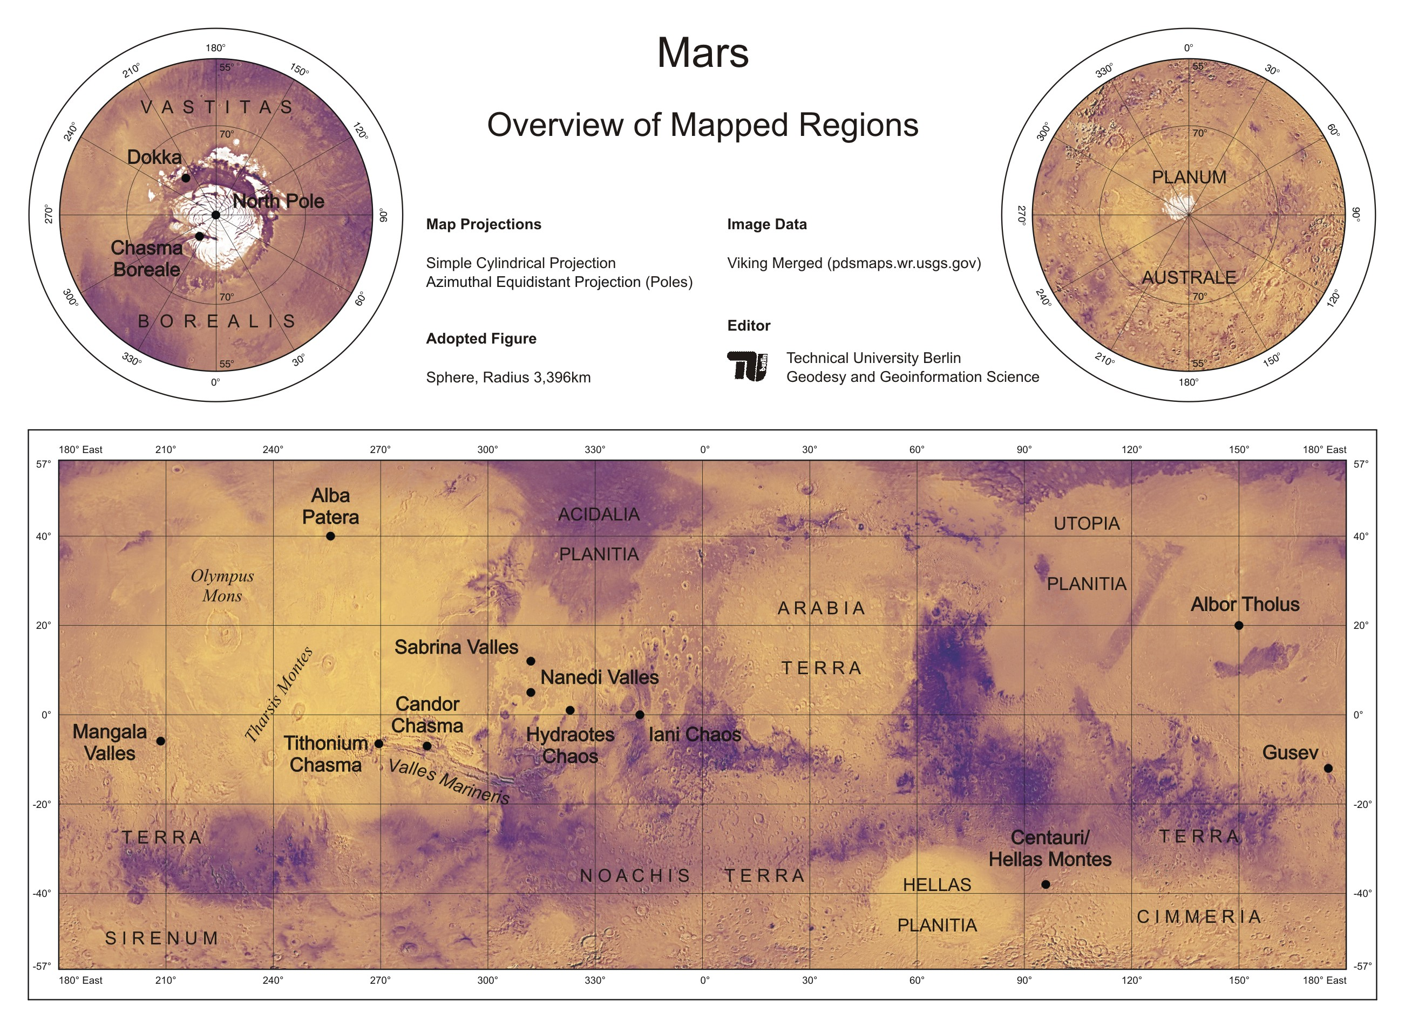

Figure 1: Location of mapped regions on Mars, based on Viking color data (USGS, 2007). Due to the small scale, individual map sheets cannot be shown.
The common Martian reference body for planimetry is a rotational ellipsoid with an equatorial axis of 3396.19 ± 0.10 km and a polar axis of 3376.20 ± 0.10 km. This parameter set is defined by the International Astronomical Union (IAU) as the Mars IAU 2000 ellipsoid (Seidelmann et al., 2002). According to IAU conventions two different types of ellipsoidal coordinate systems are in use. One consists of positive western longitudes in combination with planetographic latitudes (west/planetographic), the other one of positive eastern longitudes and planetocentric latitudes (east/planetocentric). The latter is recommended by the Mars Geodesy/Cartography Working Group (MGCWG) to be employed in future map products (Duxbury et al., 2002). Therefore, the east/ planetocentric system is defined also as the standard for Mars Express mapping (Albertz et al., 2005b).
An Areoid (Martian Geoid) is the topographic reference surface for heights (Seidelmann et al., 2004). It has been derived from Mars Global Surveyor data and is defined by the mean equatorial radius of 3396.0 km (Smith et al., 2001).

Map Products
Altogether 69 map sheets in 14 different regions have been derived from HRSC data between 2004 and early 2007 – compare Figure 1 and Table 1.

Topographic Standard Sheets
In general, considering HRSC image widths (> 60 km), adjacent orbits have to be mosaicked to cover a sheet of the Topographic Image Map Mars 1:200,000 series. However, maps within the regular sheet lines have already been accomplished in summer 2004 showing the Mangala Valles complex. Since then, several sheets of different regions of Mars have been produced (Albertz et al., 2005a, 2005b; Gehrke et al., 2006a; Gehrke et al., 2007a). Figure 2 shows two adjacent standard sheets in the north-polar region on either side of the 85° parallel, which is the transition of the two map projections. These topographic maps combine high-resolution HRSC orthoimages with contour lines from Mars Orbiter Laser Altimeter (MOLA). The sheets “M 200k 84.00N/ 315.00E OMKT” (Sinusoidal projection) and “M 200k 86.00N/326.00E OMKT” (Lambert Azimuthal projecttion) of the Topographic Image Map Mars 1:200,000 cover 2° by 18° and 2° by 24°, respectively. The depicted Chasma Boreale almost divides the ice cap and reveals (in Martian summer) layered structures of water ice and dust. Contour lines nicely fit with these layers and, moreover, give a good impression of the topography of the almost textureless ice cap (Gehrke et al., 2007a). The standard map sheet of the north pole itself has also been produced.
Systematic mapping in larger scales, i.e. 1:100,000 and 1:50,000, can be achieved by dividing standard sheets into quarters and sixteenth, respectively. The suitability of high quality HRSC data, which are both acquired under optimum conditions and adeptly processed, for mapping in those scales has been demonstrated in Iani Chaos: A triplet of topographic image maps, a standard product within the regular sheet lines of the series,
“M 200k 2.00S/343.00E OMKT”, and two derived maps, “M 100k 2.50S/343.50E OMKT” and “M 50k 2.25S/ 343.25E OMKT”, have been generated (Gehrke et al., 2006a).

Special Target Maps
Especially in the early stage of the Mars Express mission map sheets needed to be adapted to individual orbits by location and/or scale. The very first HRSC map, e.g., was a special target map of Hydraotes Chaos in 1:100,000 (Albertz et al., 2004). The “Topographic Image Map Mars 1:400,000, M 400k 11.50N/312.00E OMKT, Sabrina Vallis Region” with additional information from the Catalog of Large Martian Impact Craters has been recently presented by Gehrke et al. (2007b).

Thematic Maps
Several thematic map products have been generated in cooperation with other HRSC team members. Exemplary products are a geologic map of Gusev (Albertz et al., 2005b) and a new approach of a combined topographic-thematic map illustrating the geomorphology of Centauri and Hellas Montes (Lehmann et al., 2006). The most recent thematic product is a special target map of the Hale-Bond region by Hiesinger et al. (2007). In this area, the putative outflow channel Uzboi Vallis is heavily modified by the two impact craters. The valley floor is characterized by relatively smooth terrain between morphologically sharp blocks of eroded ejecta material (Figure 3).

HRSC DTM Test Maps
It is evident that DTMs in highest quality are indispensable for the derivation of accurate contour lines. Besides systematic processing of all HRSC data (Scholten et al., 2005) exist several enhancing and alternative approaches (Albertz et al., 2005b; Gwinner et al., 2005), which have been compared in the HRSC DTM Test (Heipke et al., 2007). Part of the evaluation process – particularly regarding the contour line quality – was the generation of topographic map sheets from all delivered DTMs in two different test areas, Nanedi Valles and Candor Chasma. These sheets follow the layout and scale of the standard map series.

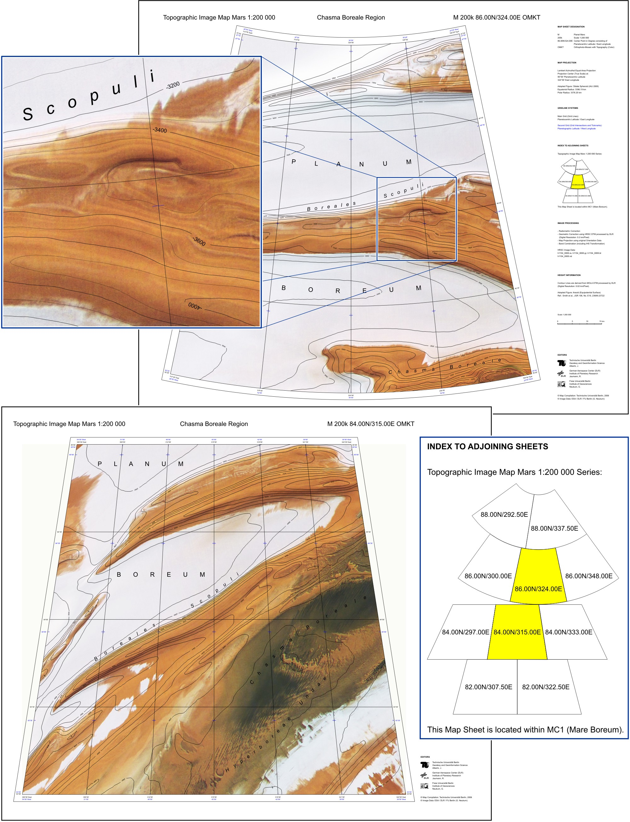

Figure 2: Map sheets “M 200k 84.00N/315.00E OMKT” in Sinusoidal projection and “M 200k 86.00N/326.00E OMKT” in Lambert Azimuthal projection. The index map (lower right image) was combined from both sheets and illustrates their relative location, with map surfaces marked in yellow, and neighboring sheets of the Topographic Image Map Mars 1:200,000 series in their projections. The subsection of the northern sheet (upper left image) is shown in scale 1:400,000, which is half of the original size.
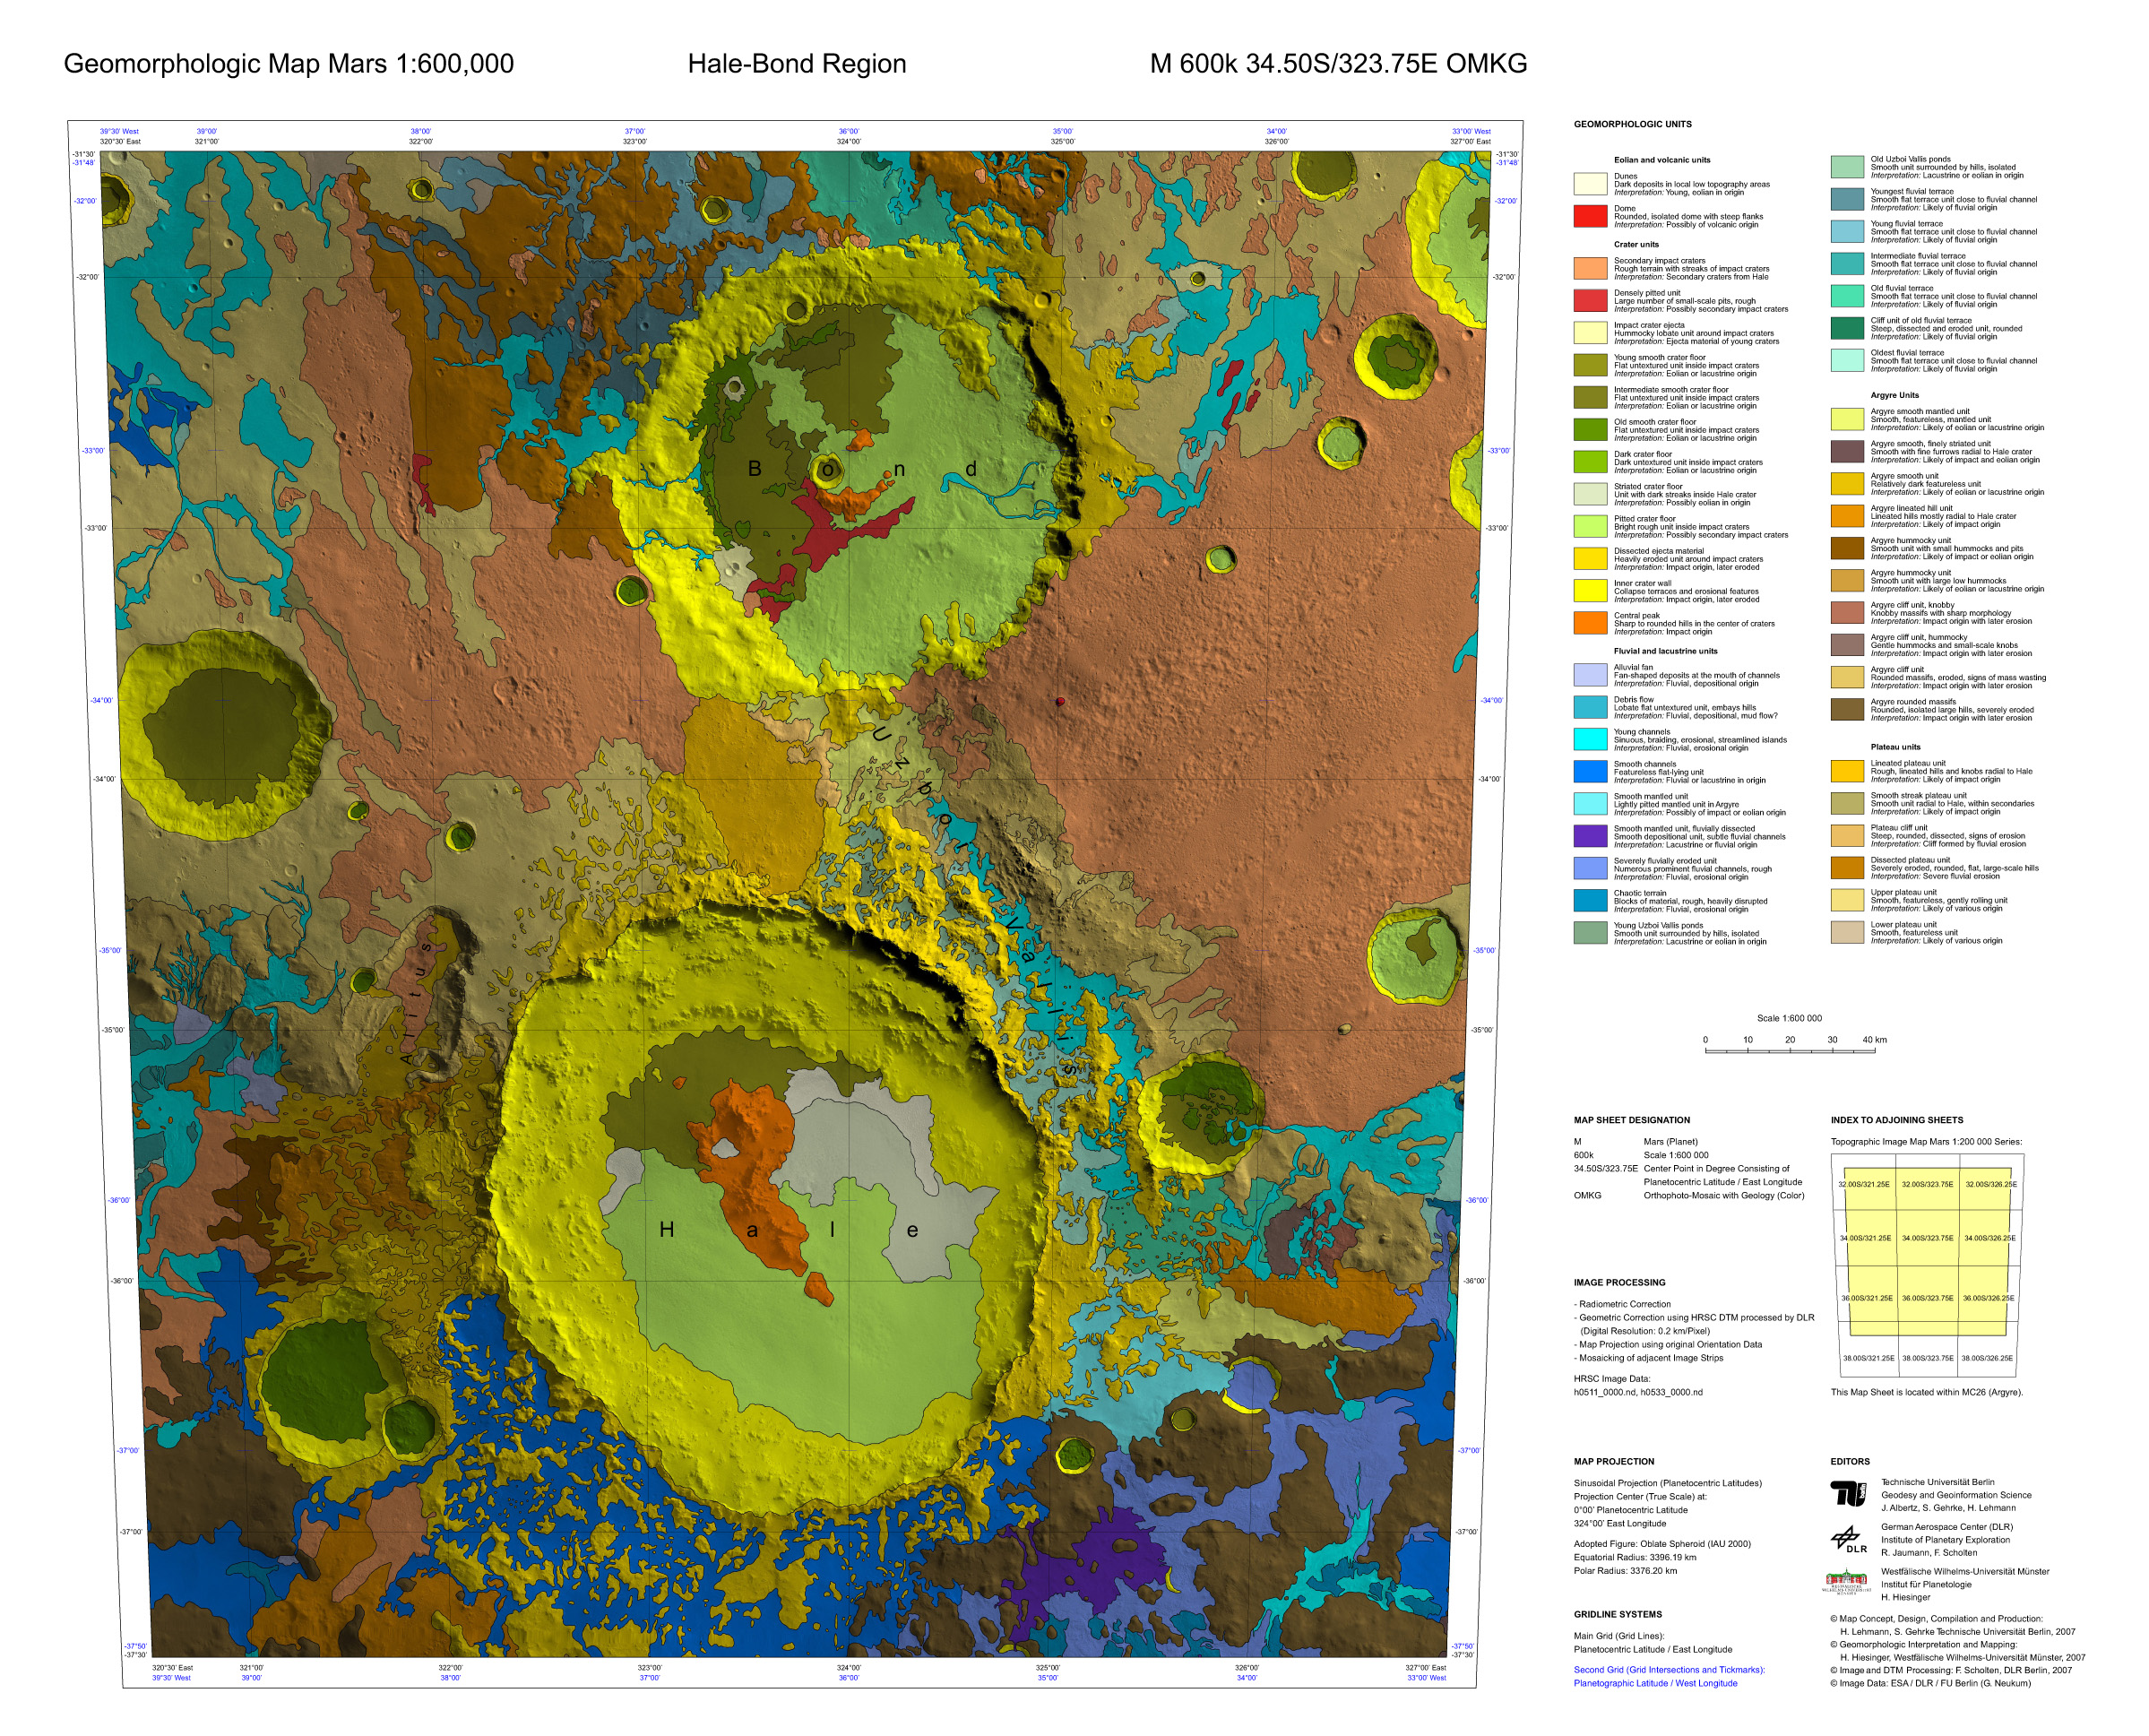

Figure 3: Geomorphologic map “M 600k 34.50S/323.75E OMKG” of the Hale and Bond crater region.

Conclusion
A variety of high quality HRSC maps in scales up to 1:50,000 is available from Technische Universität Berlin. The Topographic Image Map Mars 1:200,000 series has proven to be a useful and guide-lining standard. From the experience gained during three years HRSC cartography and operational application of PIMap it is clear that we are well prepared for systematic map generation from HRSC data.

References
Albertz, J., Gehrke, S., Wählisch, M., et al., 2004: Digital Cartography with HRSC on Mars Express. International Archives for Photogrammetry and Remote Sensing, Vol. XXXV, Istanbul, Part B4, pp. 869-874.
Albertz, J., Attwenger, M., Barrett, J., et al., 2005a. HRSC on Mars Express – Photogrammetric and Cartographic Research. Photogrammetric Engineering & Remote Sensing, Vol. 71, No. 10, pp. 1153-1166.
Albertz, J., Gehrke, S., Lehmann, H. et al., 2005b: Precise Topographic and Thematic Maps of Planet Mars. Proceedings XXII International Cartographic Conference, A Coruña.
Duxbury, T.C., Kirk, R.L., Archinal, B.A., Neumann, G.A., 2002: Mars Geodesy/Cartography Working Group Recommendations on Mars Cartographic Constants and Coordinate Systems. International Archives for Photogrammetry and Remote Sensing, Vol. XXIV, Ottawa, Part 4.
Gehrke, S., Lehmann, H., Köhring, R., et al., 2006a: Iani Chaos in Three Scales – A Topographic Image Map Mars 1:200,000 and its Subdivisions. Lunar and Planetary Science XXXVII, Houston, Paper #1325.
Gehrke S., Wählisch, M., Lehmann, H., et al., 2006b: Generation of Topographic and Thematic Planetary Maps Using the Software System “PIMap”. Lunar and Planetary Science XXXVII, Houston, Paper #1322.
Gehrke S., Bornemann, D., Wählisch, M., et al., 2007a: Combining HRSC Imagery and MOLA DTM: The First North-Polar Sheets of the “Topographic Image Map Mars 1:200,000”. Proceedings ISPRS WG IV/7 Extraterrestrial Mapping Workshop, Houston.
Gehrke S., Köhring, R., Barlow, N.G., et al., 2007b: A Topographic Image Map of the Sabrina Valles Region Including Information on Large Martian Impact Craters. Lunar and Planetary Science XXXVIII, Houston, Paper #1583.
Greeley, R., Batson, R.M., 1990: Planetary Mapping. Cambridge University Press, Cambridge.
Gwinner, K., Scholten, F., Giese, B., et al., 2005: Hochauflösende Digitale Geländemodelle der Marsoberfläche. Photogrammetrie – Fernerkundung – Geoinformation (PFG), 5/2005: 387-394.
Heipke C., Oberst, J., Albertz, J., et al., 2007: Evaluating Planetary Digital Terrain Models – The HRSC DTM Test. Planetary and Space Science, submitted.
Hiesinger, H., Lehmann, H., Gehrke, S., et al., 2007: A New Geologic Map of the Hale-Bond Region, Northern Argyre Basin. Lunar and Planetary Science XXXVIII, Houston, Paper #1997.
Kirk R.L, 2005: Mars – Grids and Datums. Photogrammetric Engineering & Remote Sensing, Vol. 71, No. 10, pp. 1111-1126.
Lehmann, H., Scholten, F., Albertz, J., et al., 1997: Mapping a Whole Planet – The New Topographic Image Map Series 1:200,000 for Planet Mars. Proceedings XVIII International Cartographic Conference, Stockholm, Vol. 3, pp. 1471–1478.
Lehmann, H., van Gasselt, S., Gehrke, S., et al., 2006: A Combined Topographic-Thematic Map of the Centauri and Hellas Montes Area, Mars. International Archives of Photogrammetry, Remote Sensing and Spatial Information Sciences, Goa, Vol. XXXV, Part B4.
Scholten, F., Gwinner, K., Roatsch, T., et al., 2005. Mars Express HRSC Data Processing – Methods and Operational Aspects. Photogrammetric Engineering & Remote Sensing, Vol. 71, No. 10, pp. 1143-1152.
Seidelmann, P.K. et al., 2002. Report of the IAU/IAG Working Group on Cartographic Coordinates and Rotational Elements of the Planets, and Satellites: 2000. Celestial Mechanics and Dynamical Astronomy, Vol. 82, pp. 83-110.
Smith, D.E. et al., 2001: Mars Orbiter Laser Altimeter: Experiment Summary after the First Year of Global Mapping of Mars. Journal of Geophysical Research, Vol. 106 (E10), pp. 23,689-23,722.
USGS, 2007: Map-a-Planet, pdsmaps.wr.usgs.gov.

